GAP Headquarters Offices
San Francisco, California
1999

The Gap Headquarters excavation sat on the Embarcadero, directly across the street from the San Francisco Bay. The water table was tidal and regularly fluctuated. PB&A, Inc. used 80 ft. long soil cement tangent piles with cross-lot bracings for the shoring design. Shoring contractors, Condon-Johnson Associates, were very successful in maintaining dry excess and a nominal amount of deformation – the maximum deformation was recorded to be ¾ of an in.
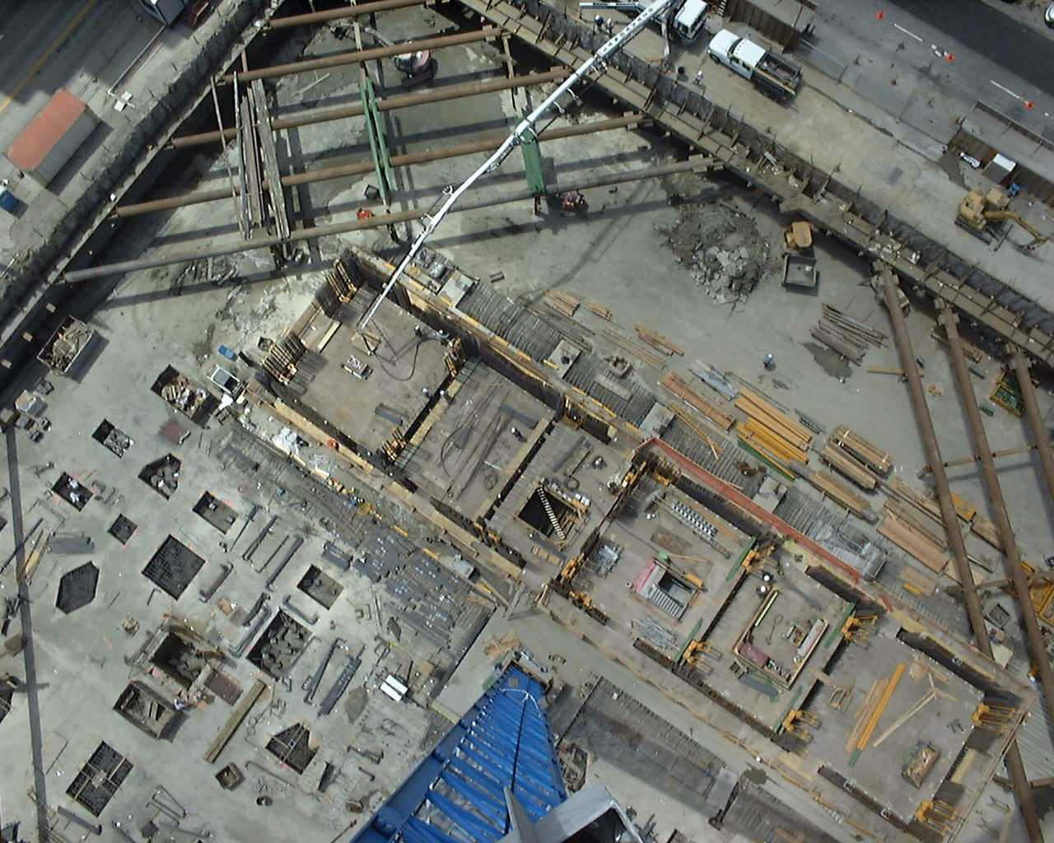

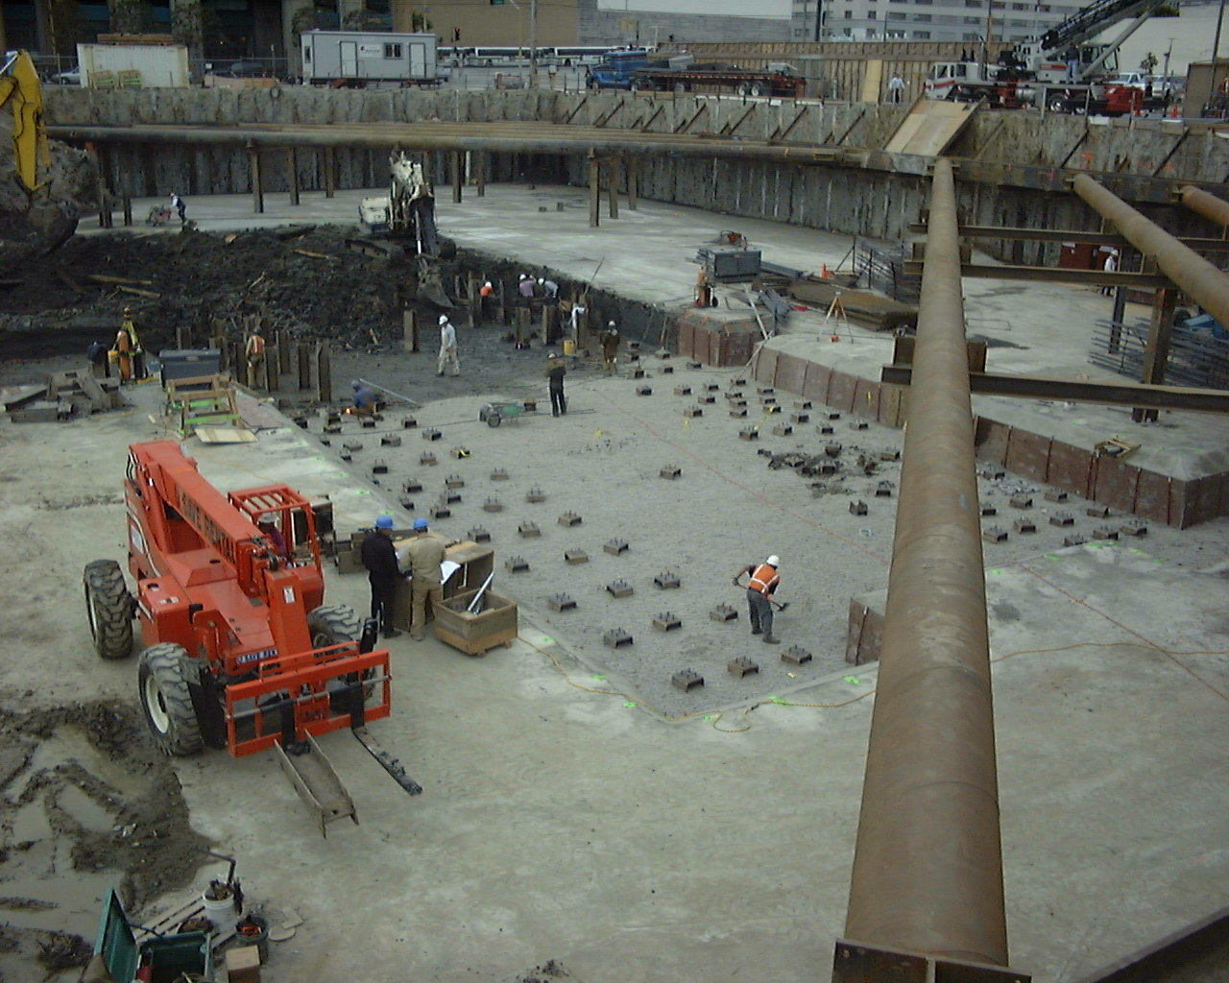
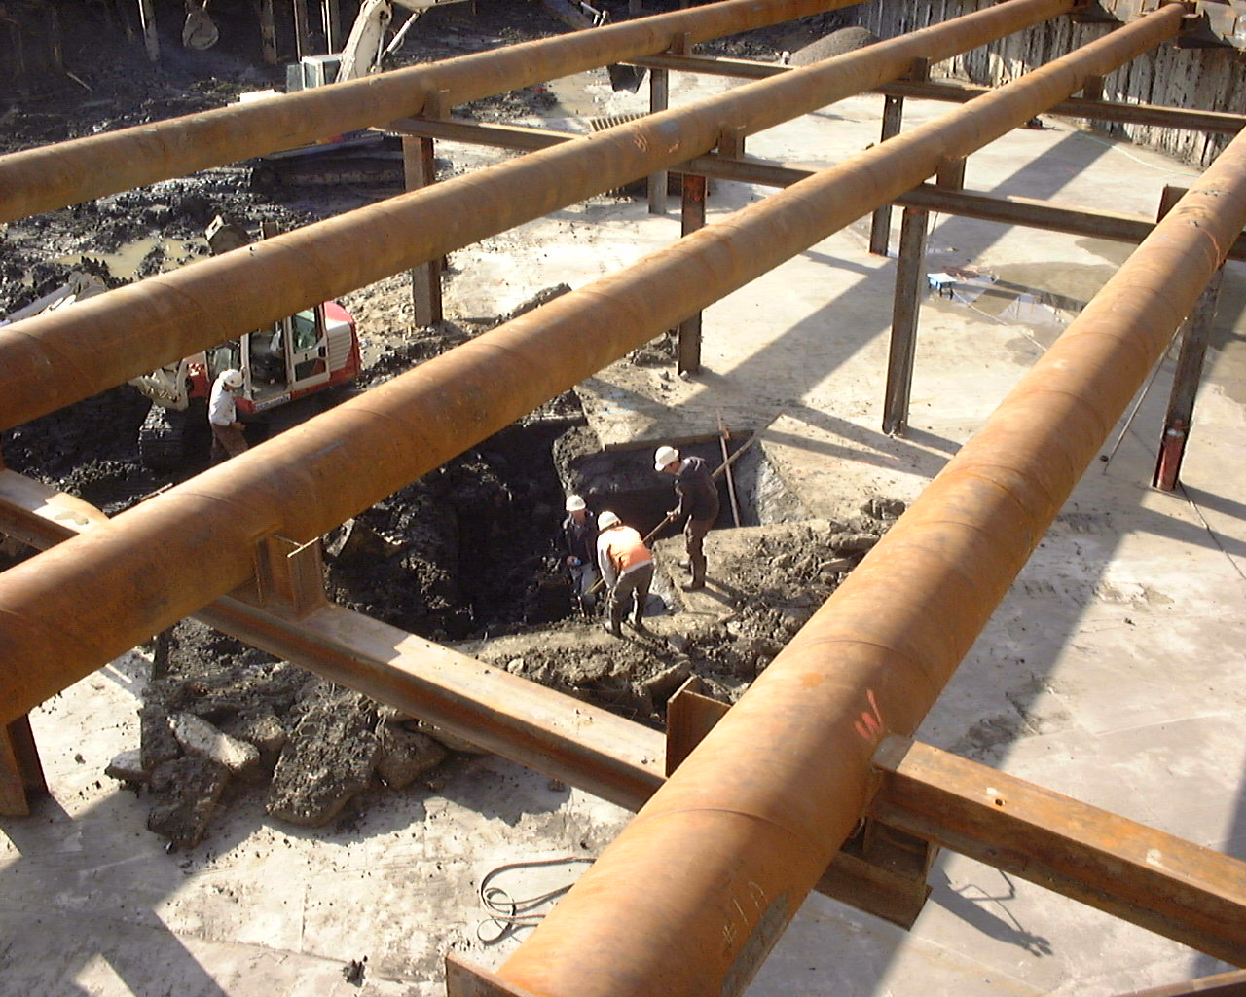
Owner GAP Corporation Shoring Cont. Condon Johnson Assoc., Inc. Shoring Engineer PB&A, Inc.

